Дата: 16.11.2021 Клас: 6-А

Тема: **Шкільні правила.**

1. ***Reading.*** *Прочитайте текст ех.3 р.57, доповніть його пропущеними словами та запишіть.*

Exercise 39

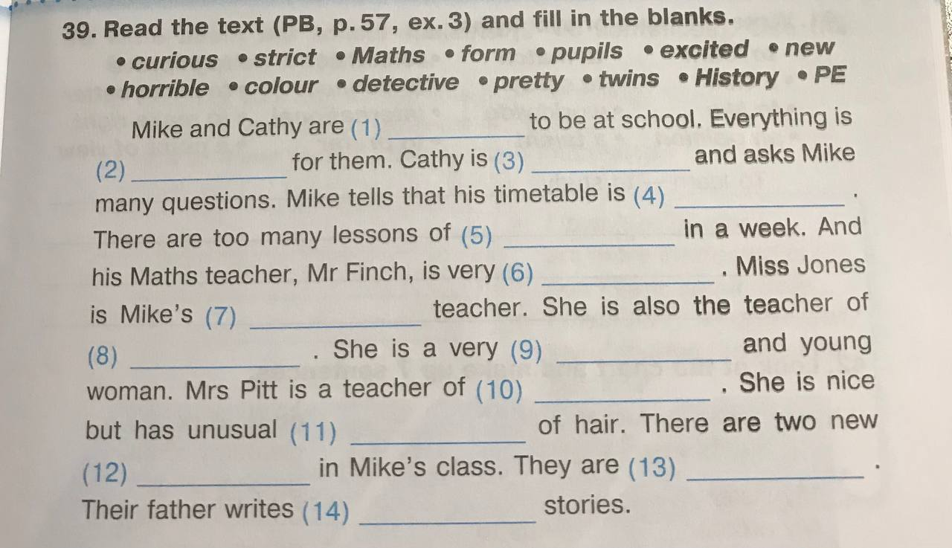

***3. Reading***

*Прочитай уважно електронне письмо від Джеймса.*

Hi, Luis!

My name is James Farrell. I’m your new e-pal. I’m from Galway in Ireland. I have got blue eyes and light brown hair. My hair is quite long. I’m not tall.

My school is called Manor Park. It isn t a very big school. It is only got 400 students. My favourite subjects are maths and science. I’ve got maths on Monday and Wednesday and science on Tuesday and Friday. I also like IT. At school we have got a special computer room.

After school we have got a lot of homework. But I have also got time for other activities. For example, I’m in the school drama club. At the weekend I’ve got guitar lessons.

Write back soon and tell me about yourself.

All the best.

James

***4. Speaking***

*Усно дайте відповіді на запитання.*

1. What is the name of your school?
2. Is your school big or small?
3. What are your favourite subjects?
4. Have you got a computer room at school?
5. Have you usually got a lot of homework?
6. Have you got any special hobbies or activities after school?

***5.Homework*** 1. Виконати письмово вправу 39 (надіслати у Human).

2. Підготуватися до підсумкової роботи, повторити стр. 48-64.